Game – Código Secreto

Opening Screen:

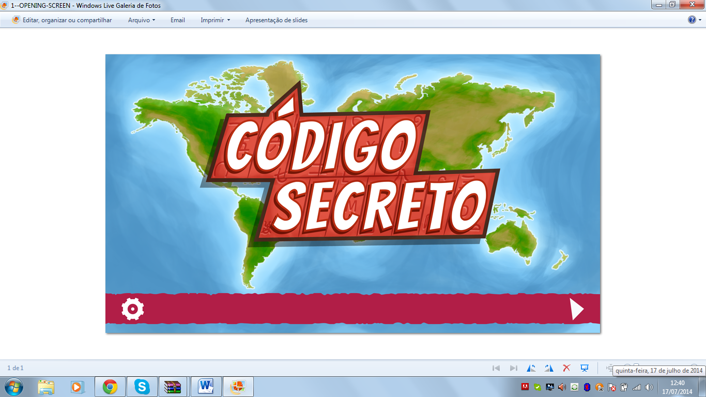

sound’s name of the opening screen:

codigosecreto_narrador_titulo.ogg

Challenge presentation:

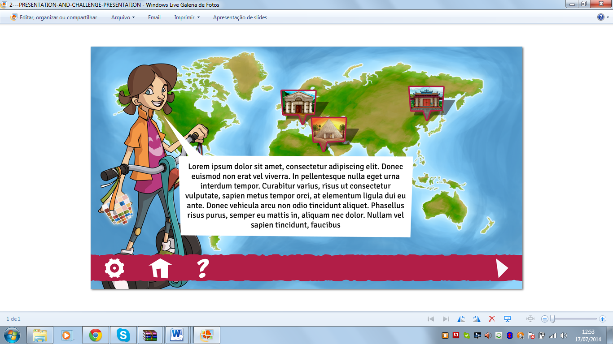

The sound’s name of the challenge presentation:

codigosecreto_silvia_challengepresentation.ogg

Positive feedback:

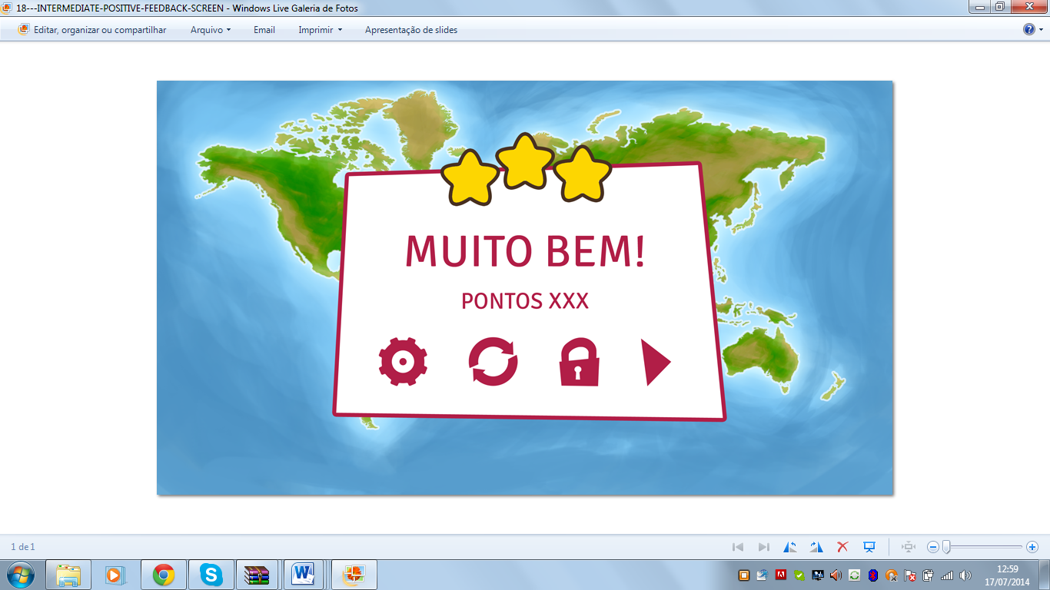

The sound’s name of the positive feedback:

codigosecreto_silvia_intermediatepositivefeedback.ogg

Final Positive Feedback:

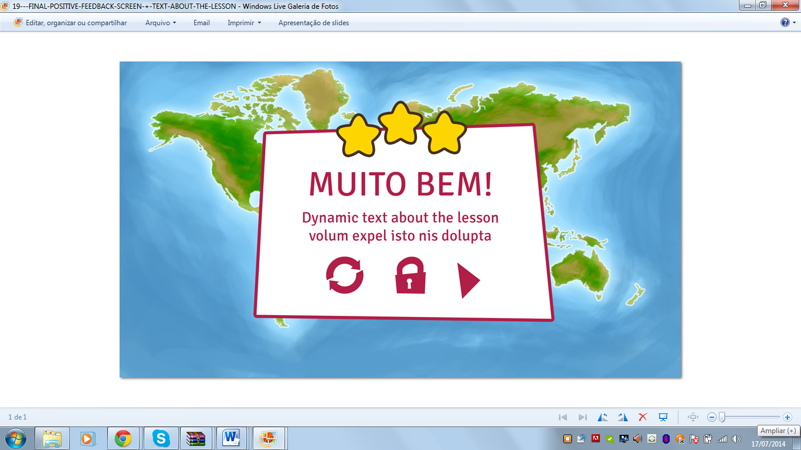

The sound’s name of the positive feedback:

codigosecreto_silvia_finalfeedback.ogg

Game level 1:

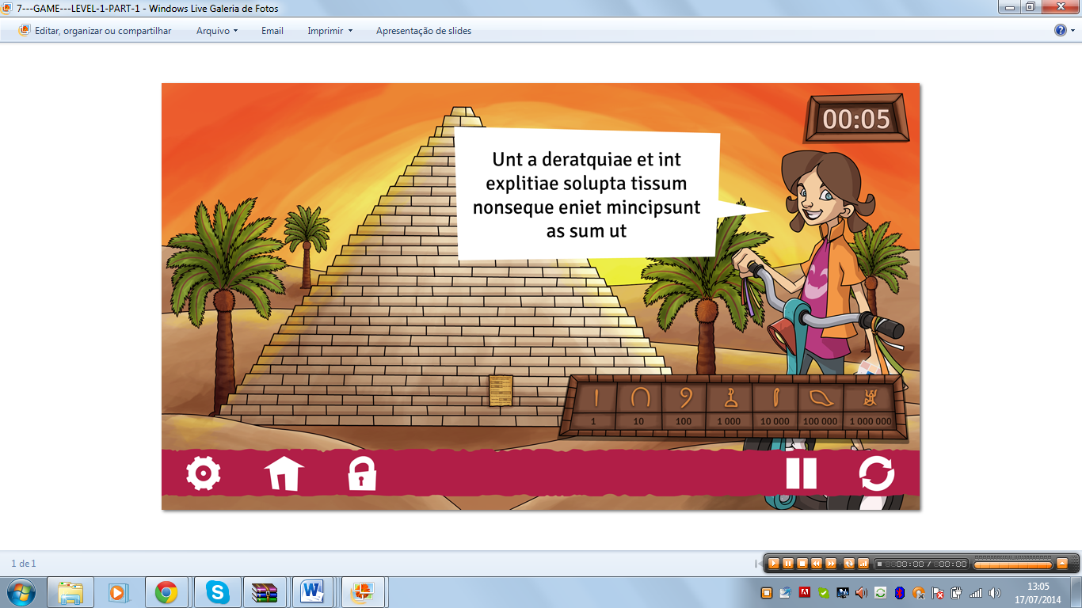

The sound’s name of the game level 1:

codigosecreto_silvia_tela1.ogg

Game level 1-1:

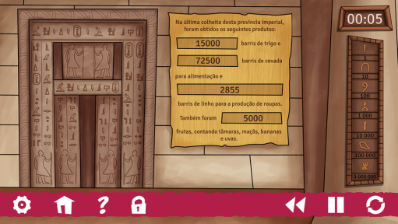

The sound’s name of the game level 1-1:

codigosecreto_silvia_tela2.ogg

Game level 2:

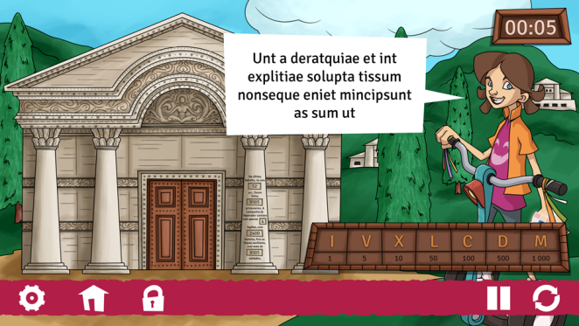

The sound’s name of the game level 2:

**codigosecreto_silvia_level2part1_tela1.ogg**

Game level 2-2:

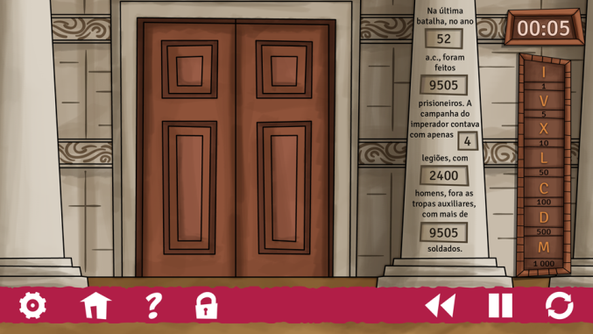

The sound’s name of the game level 2-2:

**codigosecreto_silvia_level2part1_tela2.ogg**

Game level 3:

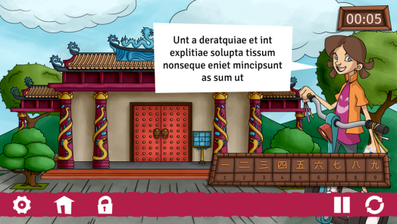

The sound’s name of the game level 3:

codigosecreto_silvia_level3_tela1.ogg

Negative Feedback level 1:

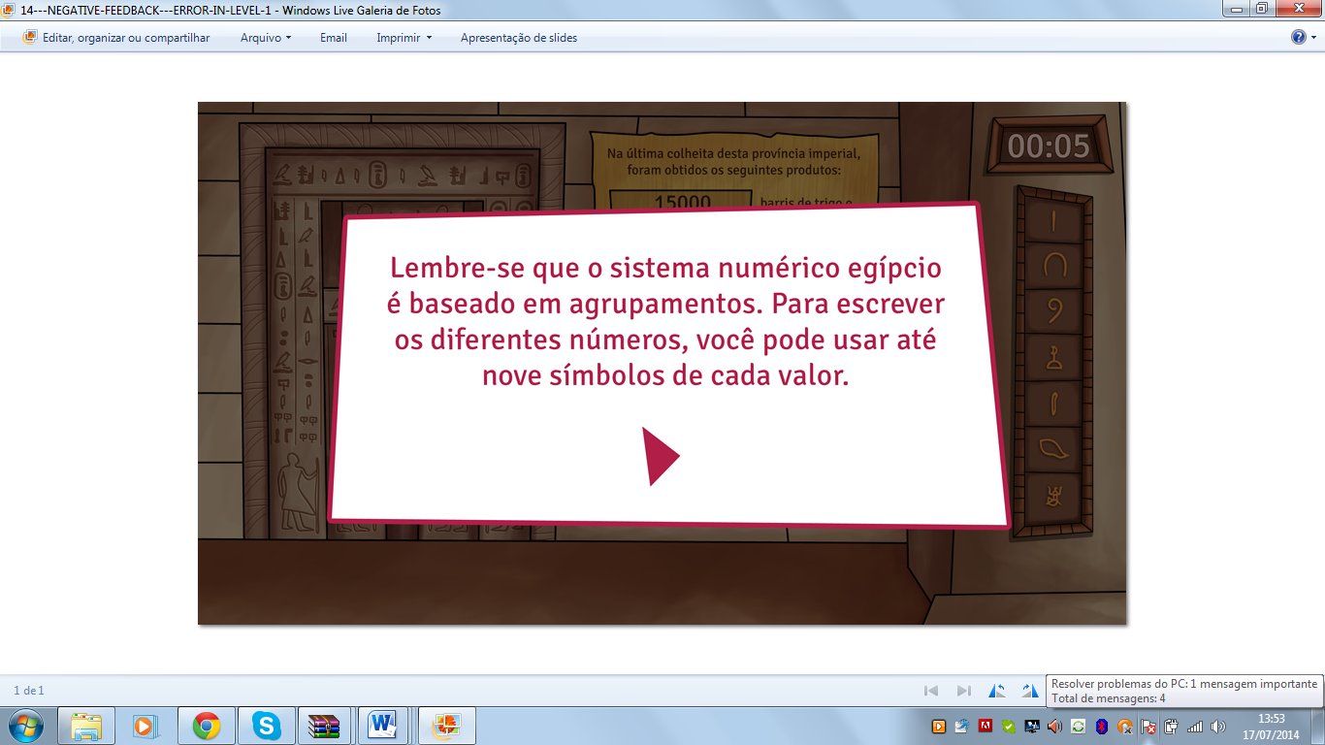

The sound’s name of the negative Feedback level 1:

codigosecreto_silvia_negativefeedbacklevel1.ogg

Negative Feedback level 2:

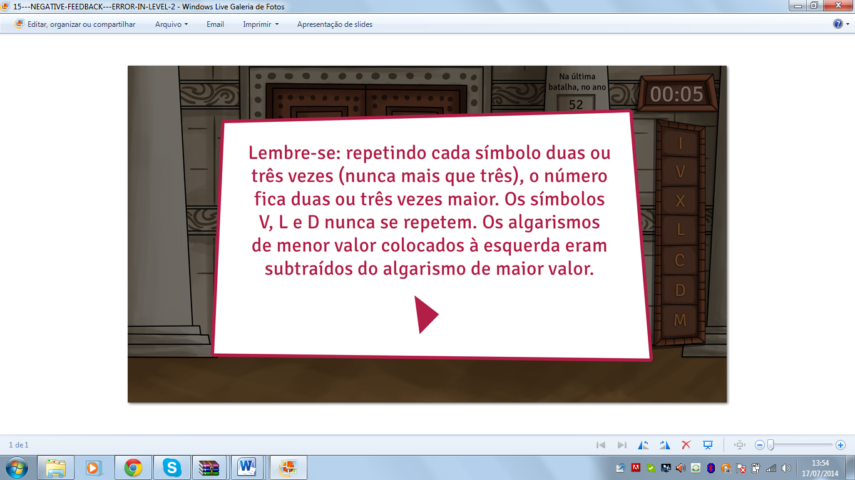

The sound’s name of the negative feedback level 2:

codigosecreto_silvia_negativefeedbacklevel2.ogg

Negative Feedback level 3:

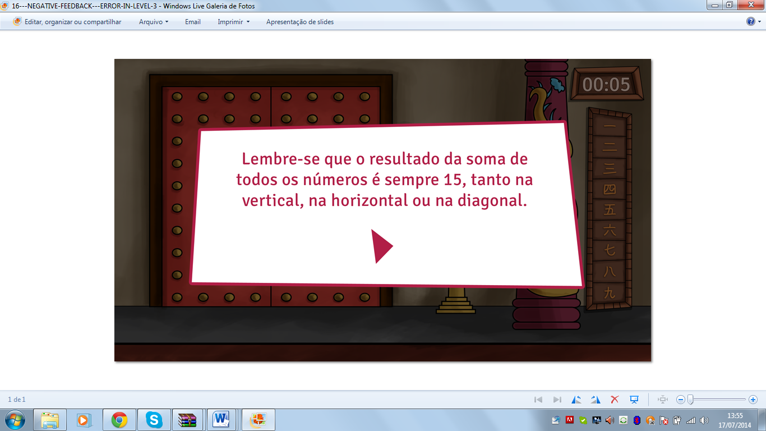

The sound’s name of the negative feedback level 3:

codigosecreto_silvia_negativefeedbacklevel3.ogg

Negative Feedback (time is over):

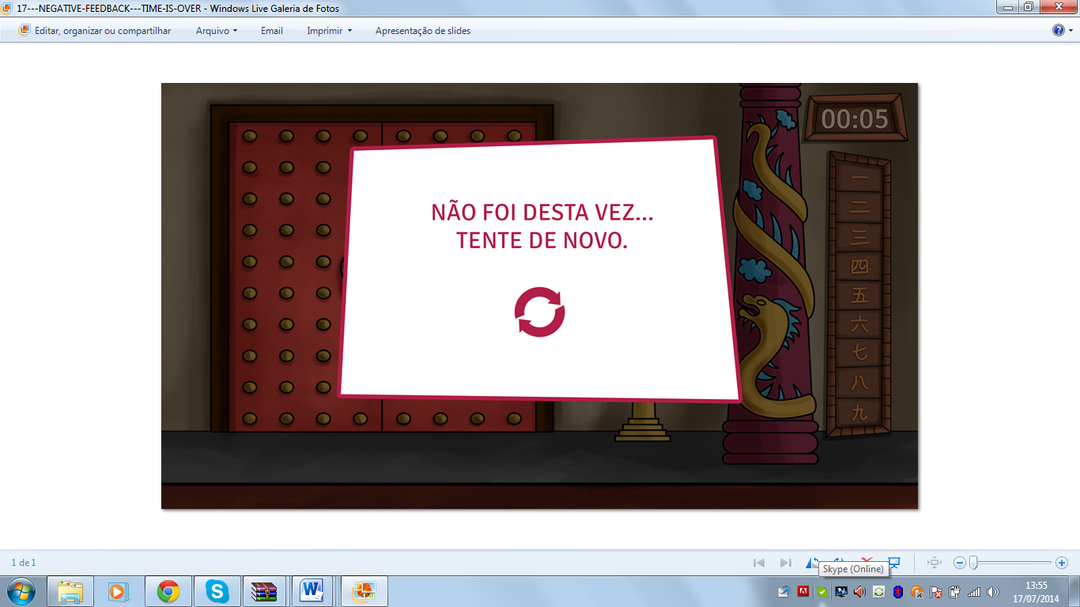

The sound’s name of the negative feedback (time is over):

codigosecreto_silvia_negativefeedback_timeover.ogg

Tutorial screen part 1:

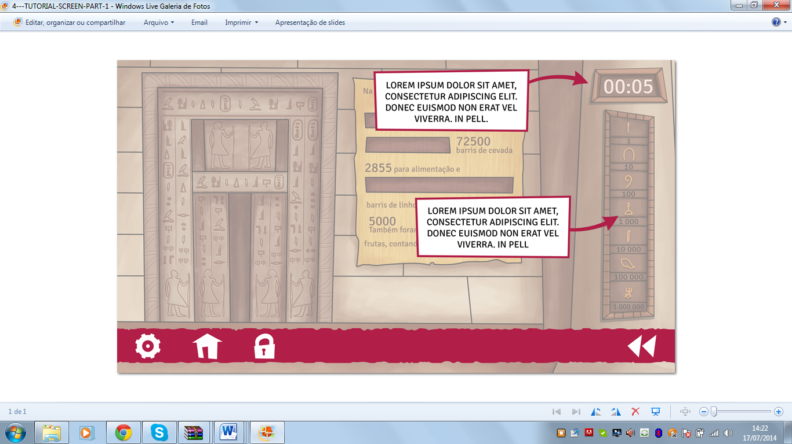

The sound’s name of the tutorial screen part 1:

Ponting to the number: codigosecreto_silvia_tutorialscreen1_tutorial1.ogg

Ponting to the symble: codigosecreto_silvia_tutorialscreen1_tutorial2.ogg

Tutorial screen part 2:

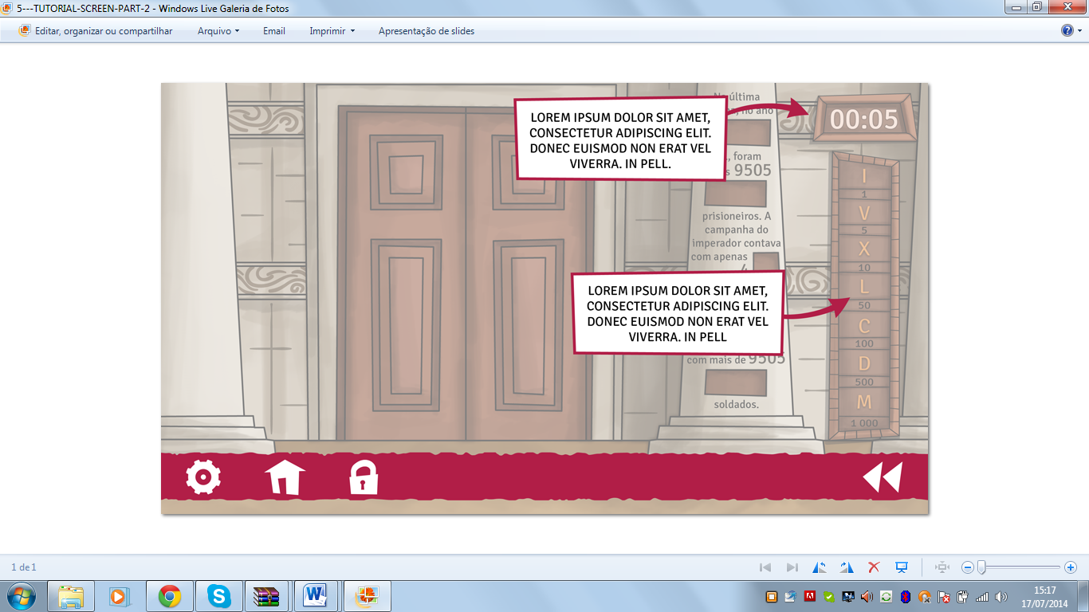

Ponting to the number: codigosecreto_silvia_tutorialscreen2_tutorial1.ogg

Ponting to the symble: codigosecreto_silvia_tutorialscreen2_tutorial2.ogg

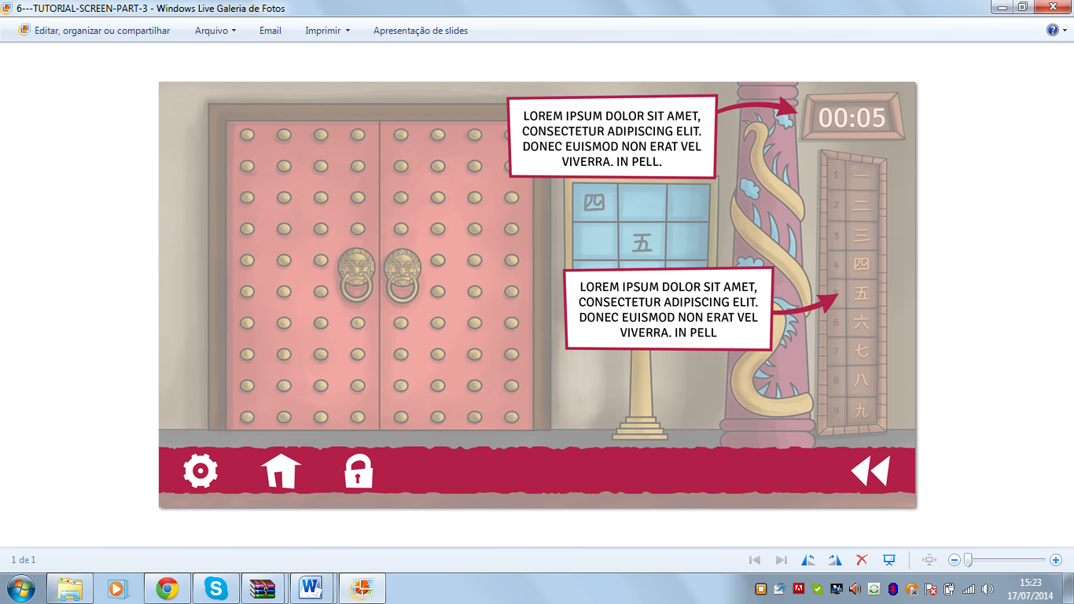

Ponting to the number: codigosecreto_silvia_tutorialscreen3_tutorial1.ogg

Ponting to the symble: codigosecreto_silvia_tutorialscreen3_tutorial2.ogg

Pause Screen:

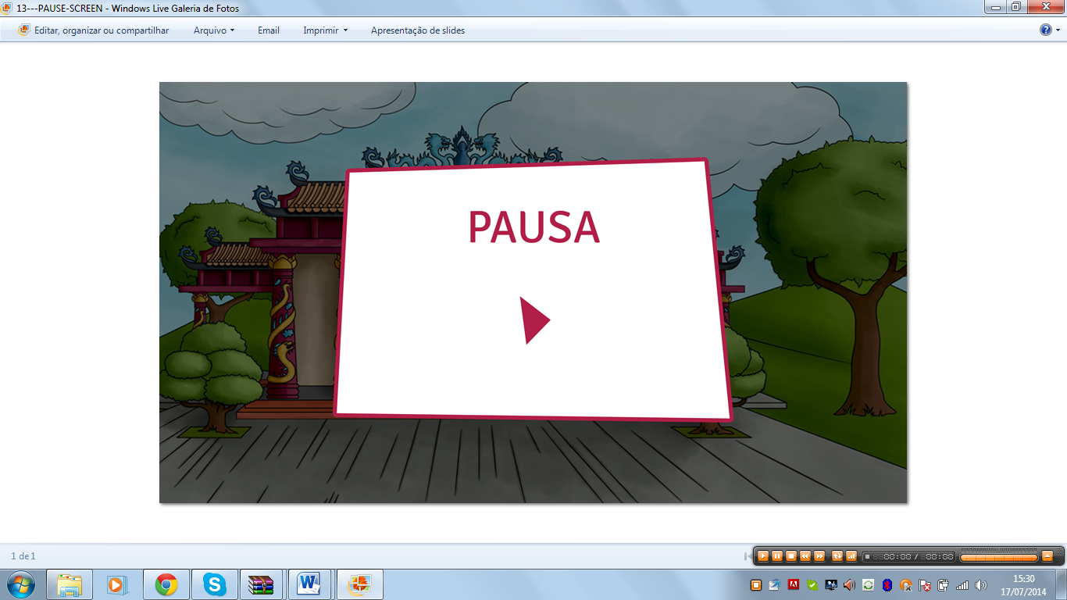

codigosecreto_silvia_pausescreen.ogg

Quit screen:

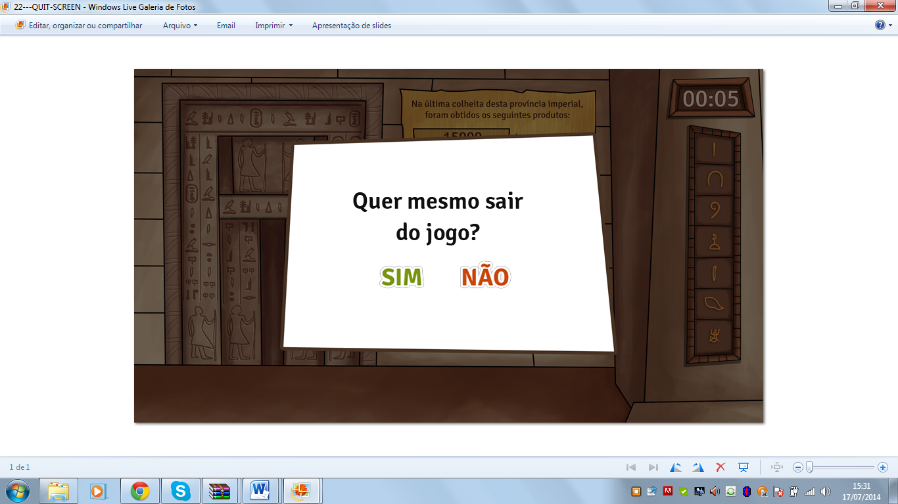

codigosecreto_silvia_quitscreen.ogg